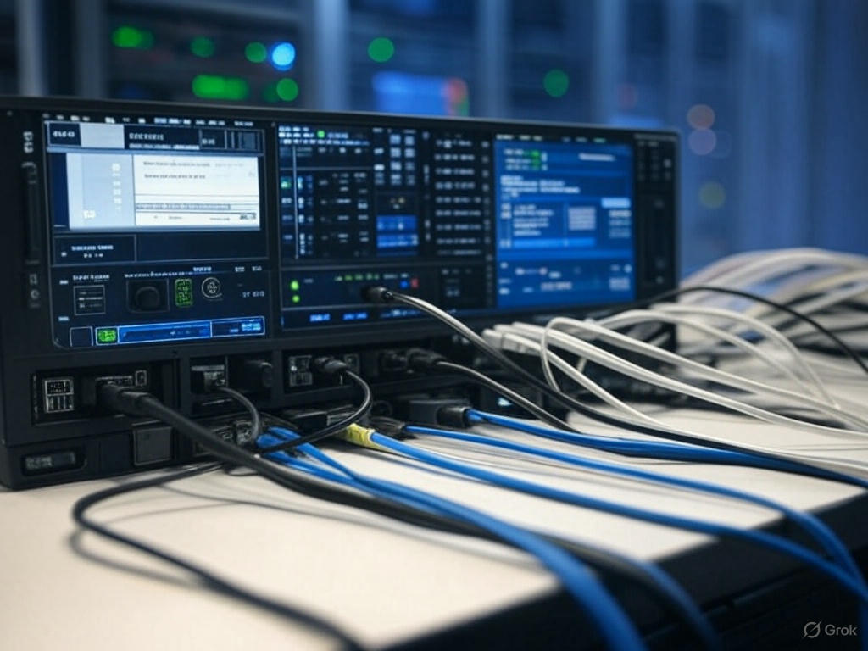 Assigning Multiple Instances to a VLAN Simultaneously

Ronique Young

3/9/2025

Project Objective:

For this project, my goal is to demonstrate how to configure multiple interfaces on a switch that shares the same settings all at once, rather than configuring them individually. This approach saves time and ensures consistency across the interfaces.

Project Purpose:

Being able to configure multiple switch interfaces simultaneously is a key skill in network management. For example, high-end Cisco Catalyst Switches can have over 500 interfaces, many of which might need nearly identical configurations. In real-world scenarios like this, configuring each interface one by one simply isn’t practical. Through this project, I’ll show how to streamline the process effectively.

Configuring VLANs and Macros on a Cisco Switch

For this project, I’m walking through a series of tasks to set up and manage VLANs on a lab switch, showcasing efficient configuration techniques using macros. Here’s how I approached it:

Task 1: Setting the Hostname

My first step was to personalize the lab switch by assigning it to the hostname of my choice. I made sure the switch has at least 24 ports to work with, giving me plenty of interfaces to configure for this project.

Task 2: Creating VLANs

Next, I set up two VLANs on the switch. I created VLAN 10 and named it “SALES” to represent a sales department network, and VLAN 20, named “TECH,” for a technical team network. This step establishes the foundation for organizing the switch’s traffic.

Task 3: Building Configuration Macros

To make the configuration process smoother, I designed two macros. The first, called “VLAN_10_Macro,” handles the setup for ports FastEthernet0/1 through FastEthernet0/12, assigning them to VLAN 10. The second, “VLAN_20_Macro,” does the same for ports FastEthernet0/13 through FastEthernet0/24, linking them to VLAN 20. For this project, I avoided the interface range command since the focus is on practicing macro-based configuration.

Task 4: Applying Macros to Interfaces

Note: The command define interface-range VLAN_10_Macro FastEthernet 0/1 - 12 has been tested and confirmed not to work on the Cisco 3560-24PS switch in Cisco Packet Tracer. This switch does not support the macro configuration as expected for this task.

CLICK HERE FOR THE BREAKDOWN